Hand Crank Projector Unit

Prototype Documentation

By:

Ben Wrigley

Matt Little matt@re-innovation.co.uk

Date: 12/7/2016

Overview
This project is to design a self powered projection unit for 16mm film.
The concept is for a self-contained unit which can be used to show short 16mm film loops along with sound tracks.
The unit needs to be powered by the user and project onto a small screen in front of the user.
This document covers the initial design of a prototype, highlight design decisions made and suggest future improvements.
It is important to note that this is a prototype unit to show that such a system is feasible. Suggestions and improvements are discussed.

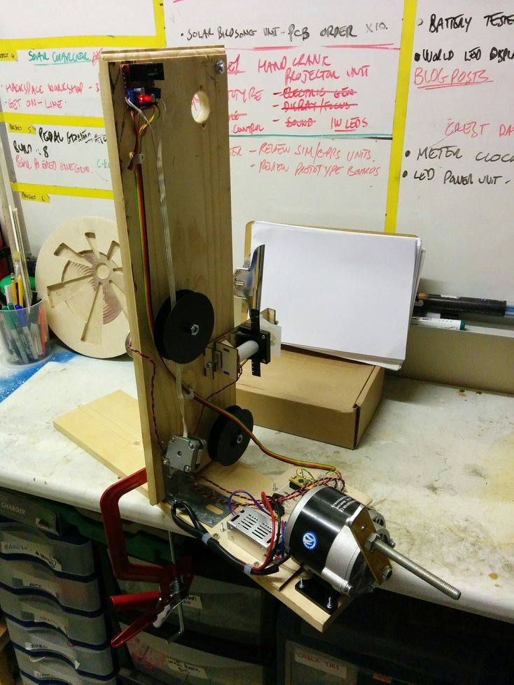

Projection Unit

Here is a good overview of how a 16mm film projector works:
https://www.youtube.com/watch?v=En__V0oEJsU

A film projector displays a moving image from a series of still images. To do this the film must be moved forward one frame. This is then lit from the back and projected. The image is the focussed onto a screen using a lens.
The next image is then moved on and the process happens again.

Typically this is done at a rate of around 25 frames per second.
Due to the complexity involved, this project aims for a rate of 6 frames per second.

We set up a set of three reels which hold the film. This passes through a projection system (with lens and light source).
To extend the film clip we are using a series of rollers which extends the length of available film.

Issues:
Frame speed is limited by time taken to move the reel. Approximately 4-5 frames per second is achieved here.
This means that a flashing can be seen between each frame.

Reel Control Motor
The size of 16mm film is shown here:
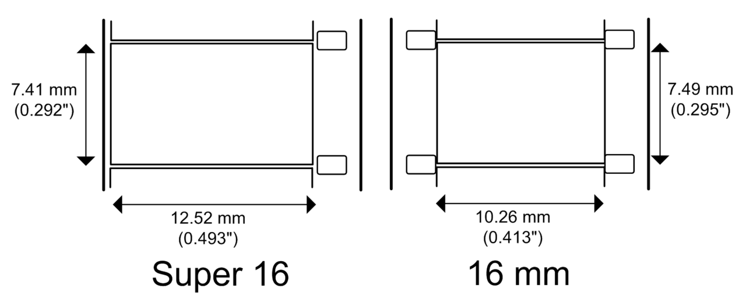

This uses a toothed reel which was designed and then cut on a laser cutter. Small teeth fit the film and align with the small holes on the film. This pulls the film on.

A stepper motor is used to pull the film through the projection system by one frame each time. A stepper motor is used as it can be controlled to move the film on by exactly one frame.
We are using the 28BYJ-48 stepper motor with driver
This Motor has a Gear ratio of 64 , and Stride Angle 5.625°
so this motor has a 4096 Steps .
More information is available here:
http://42bots.com/tutorials/28byj-48-stepper-motor-with-uln2003-driver-and-arduino-uno/
Gear ratio is: 64 approx :1
Actual gear ratio: 63.68395 : 1
Here are images of the stepper motor and reel holder mechanism:

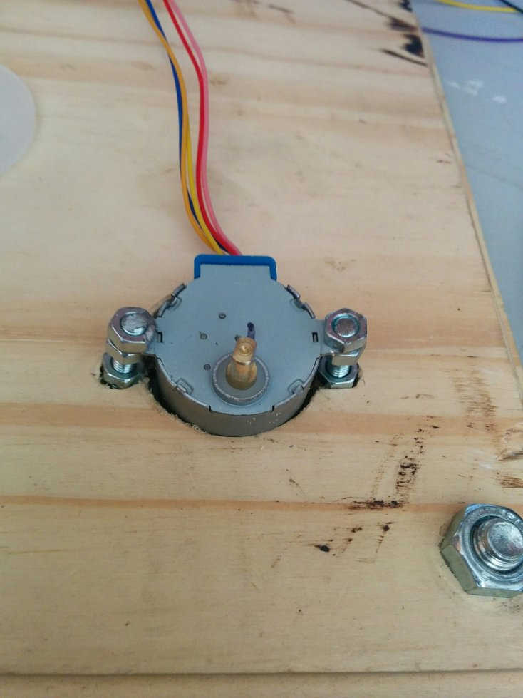

The stepper motor is geared down and, due to this, it cannot spin fast enough to give the frame rate required. A faster stepper motor and driver has been ordered to solve this issue.

Issue: Gearing meant that this stepper motor does spin fast enough. New stepper motor and driver has been obtained and fitted.

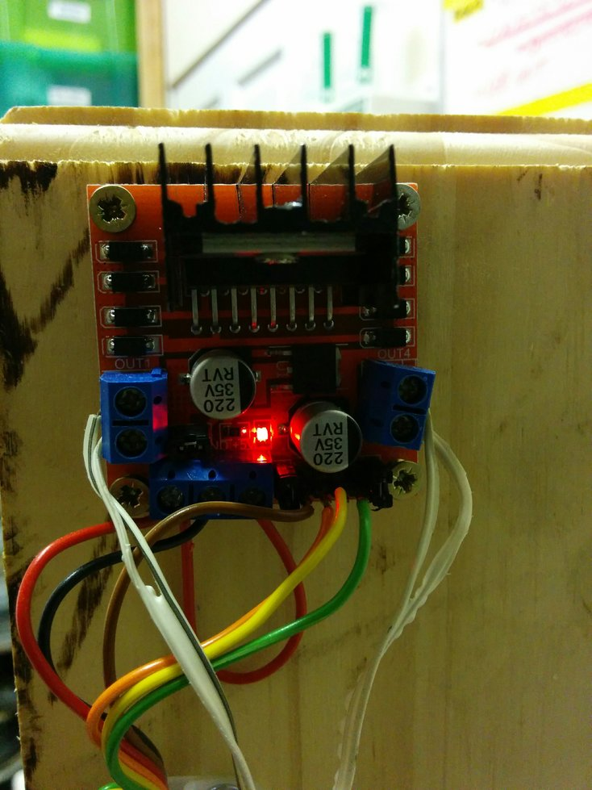

Issue: Reel holder requires thin plastic (<1mm) to pull on the film. This was ordered but has not yet been received. This will be laser cut to finish off the toothed reel holder for the stepper motor.

Projection System
The projection system uses a set of 4 ultra-bright white LEDs. This shine behind the film. the image is then magnified and focussed by a 25mm lens with a focal length of 20mm.

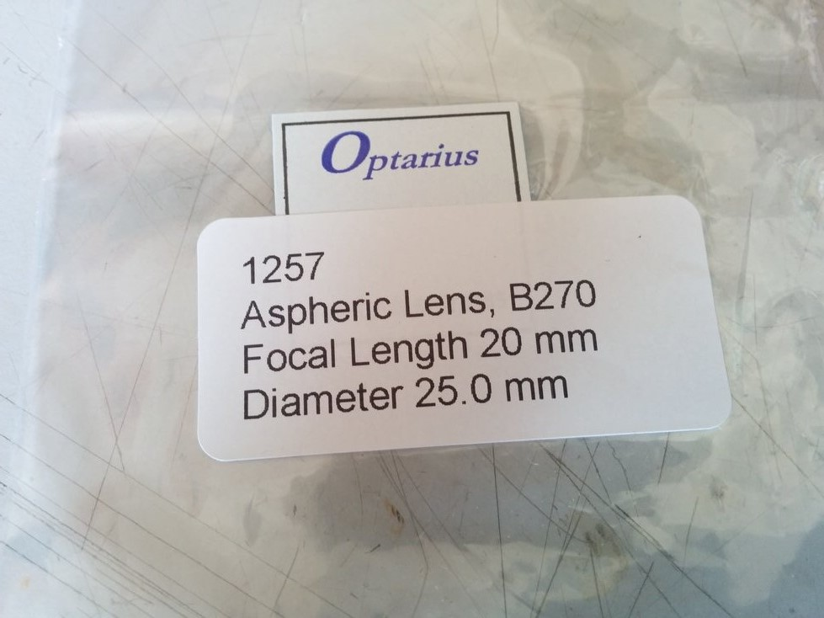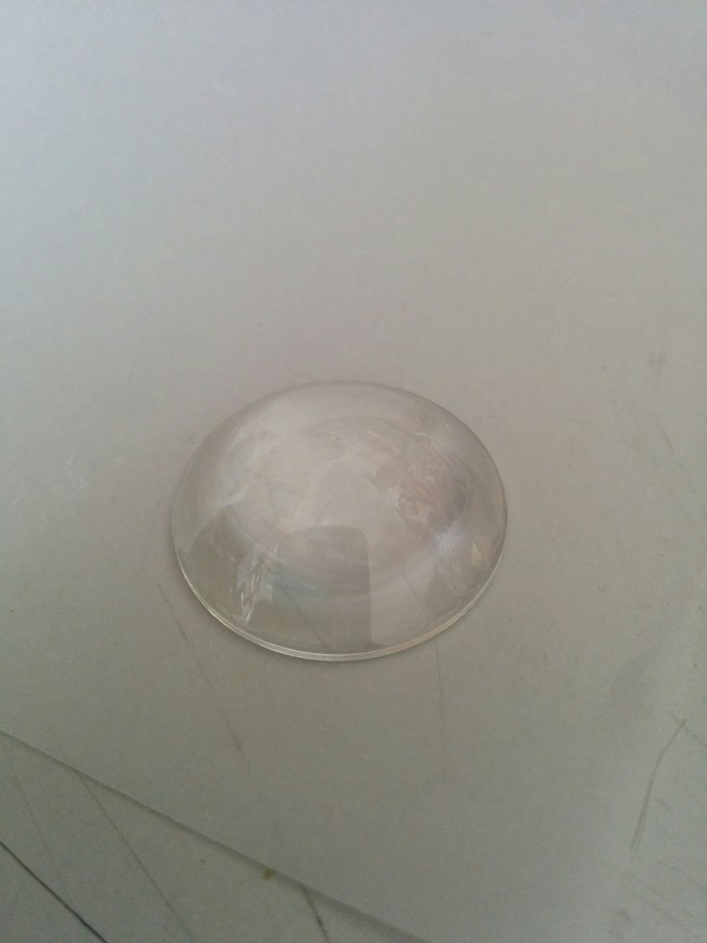

A laser cut film holder and focus adjustment system has been designed. Threaded rod allows the lens and the LED lights to be adjusted to focus the image to different distances. A tube stops external light and reflections from affecting the image.

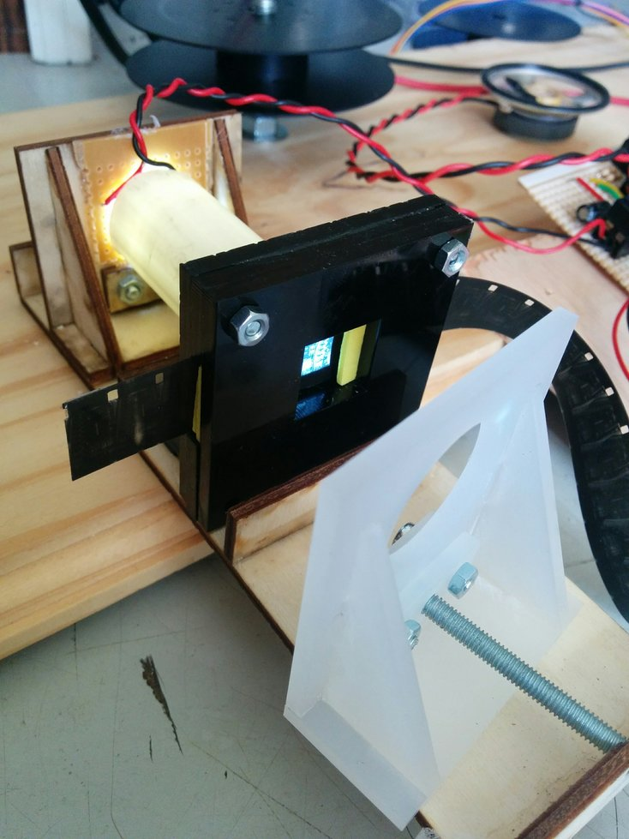

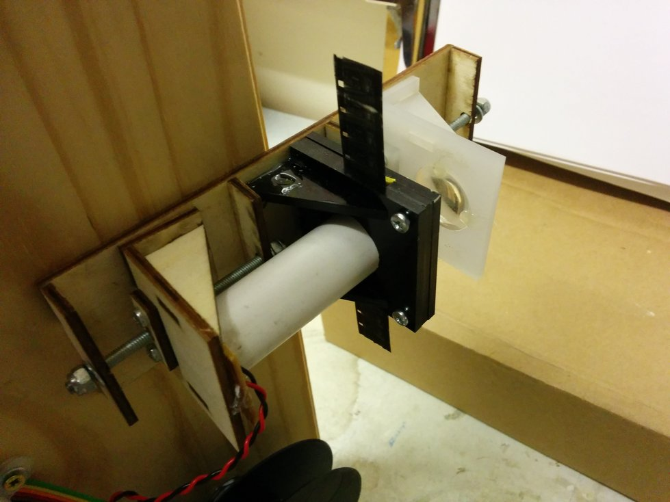

Issue: Light getting in around the sides of the film.
Solved: Added layers of foam to fill the gap and keep the film in the correct position. This might have the problem of wear on the film over time.

Still frame projection

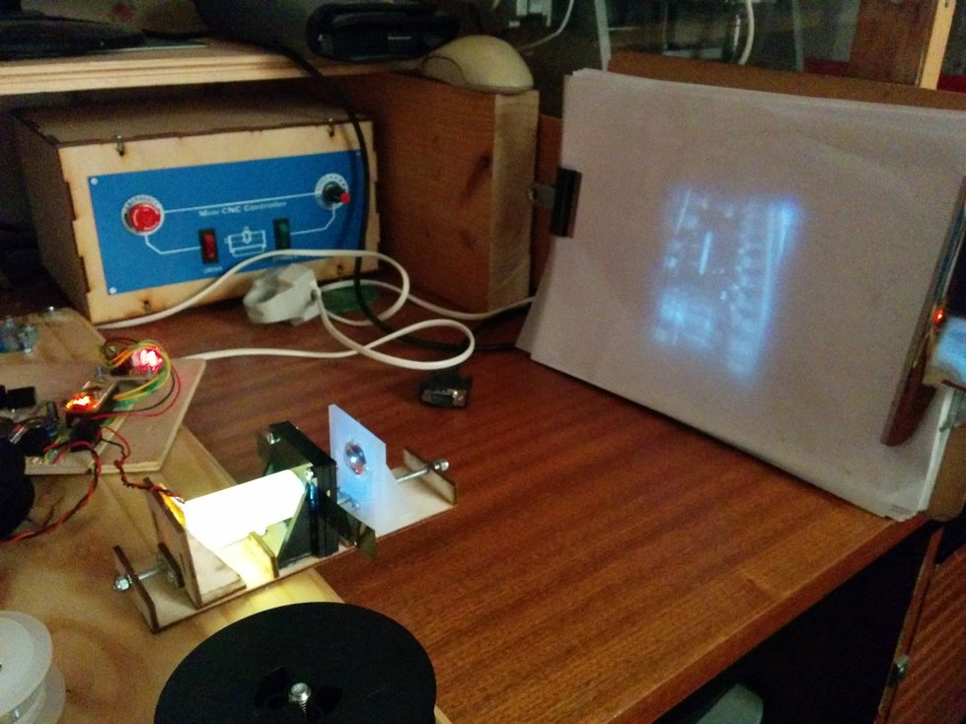

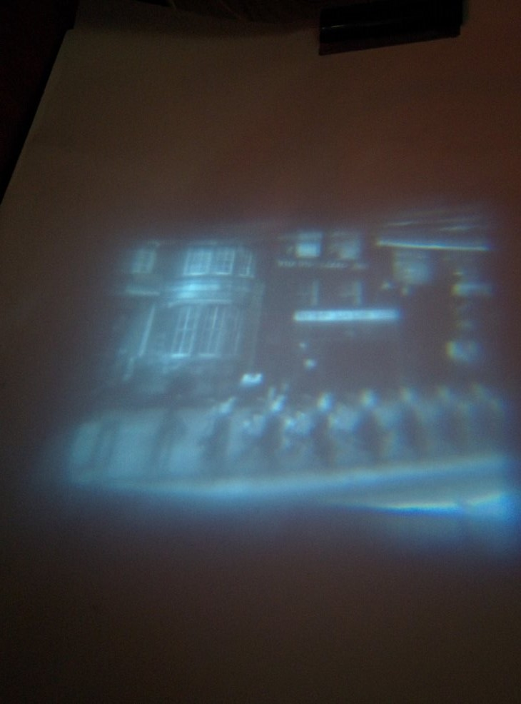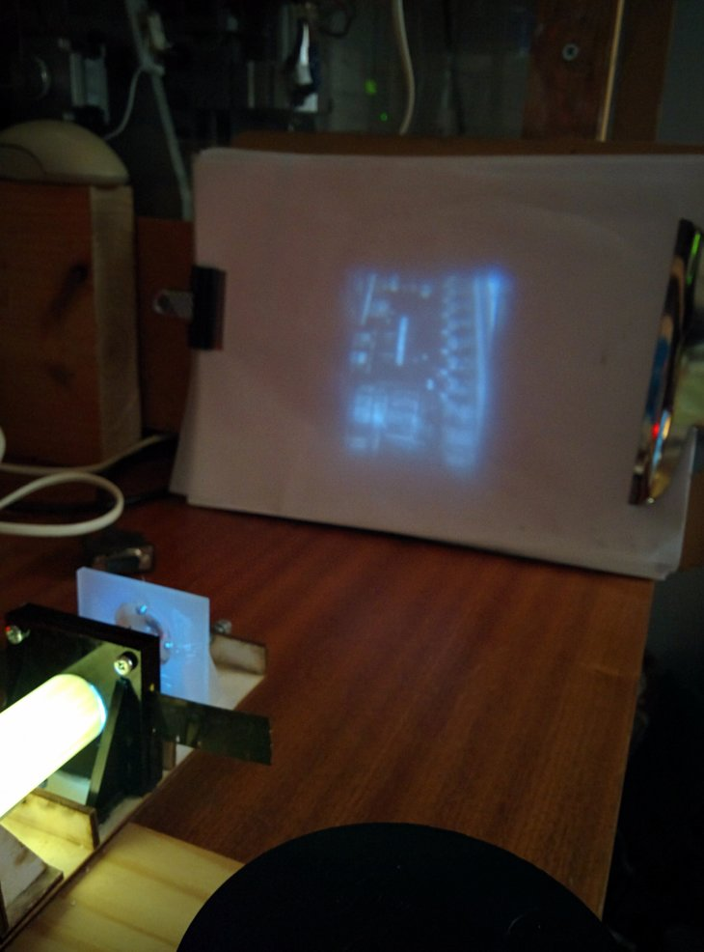

Hand Crank Power Supply
Power is provided by the user who turns a hand crank. This provides energy to the system.
A geared high-power motor is used, along with a hand crank, to provide the power. This motor is designed for powering scooters and is available 'off-the-shelf'.

A regulator is used to smooth the voltage to 5V DC. Some capacitors smooth that 5V DC and provide some buffer to ensure smooth control over the unit.

The voltage of the hand crank is monitored and only when there is enough power does the film start to play.

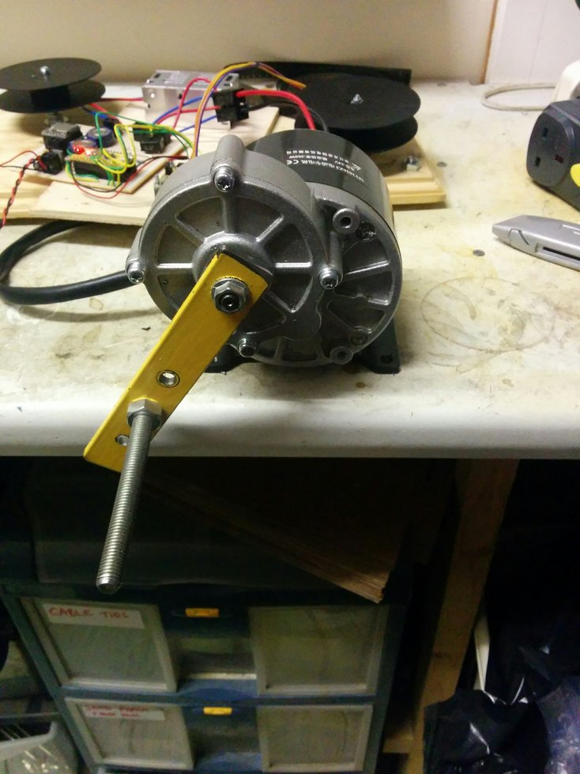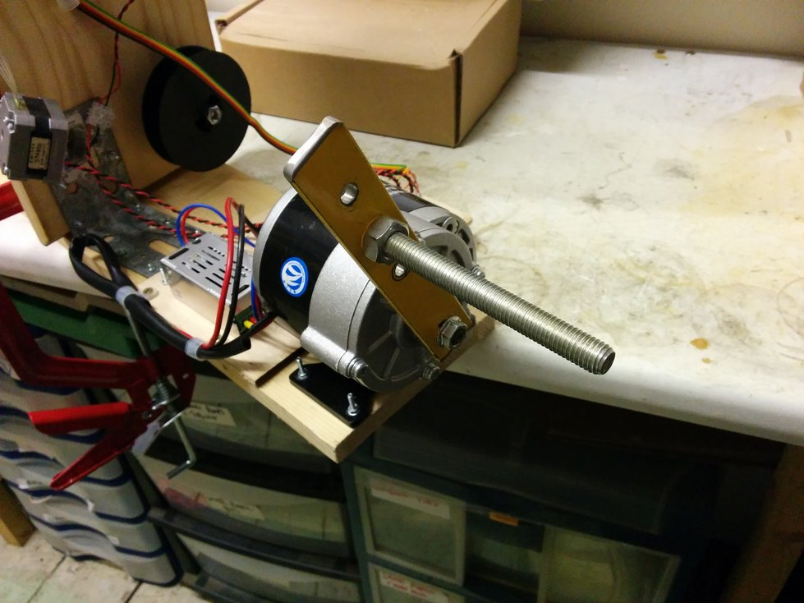

Issue: This needs to be rotated quite quickly to produce the 5V required to run everything. Either additional gearing required or a buck-boost DC-DC converter required.

Issue: The generator is quite noisy. This might be amplified as it is bolted to a piece of wood. Potentially rubber fixing could be used to reduce sound transfer.

Control System
To control the stepper motor, LED light unit and the sound an Arduino Nano is used. This is a reprogrammable microcontroller which controls all the units functions.
This also monitors the voltage from the hand crank unit to know when to switch on/off and to move the projection forwards.
We use this to test different functions

Code example: See Appendix.

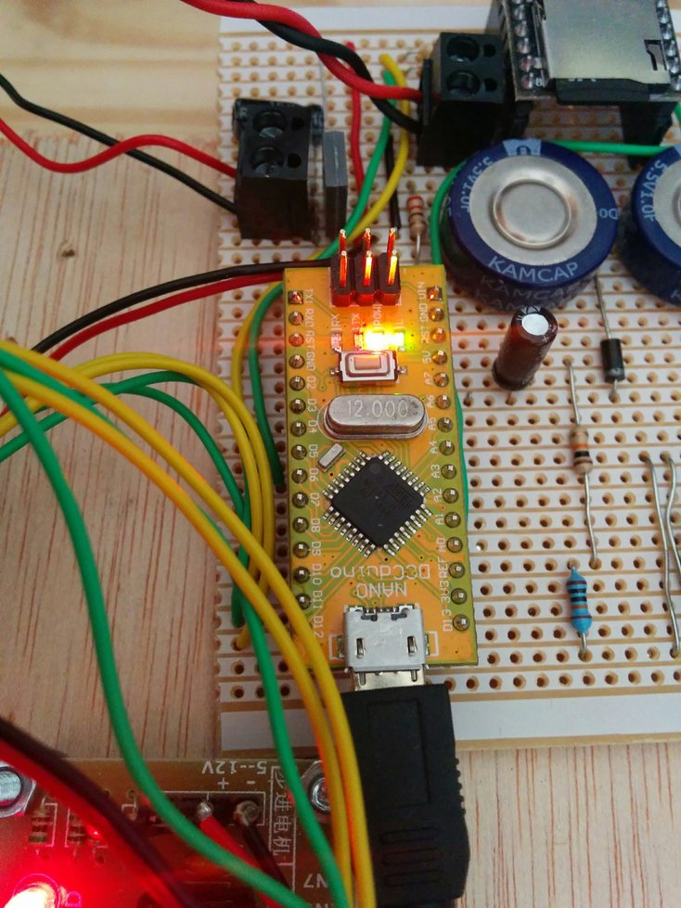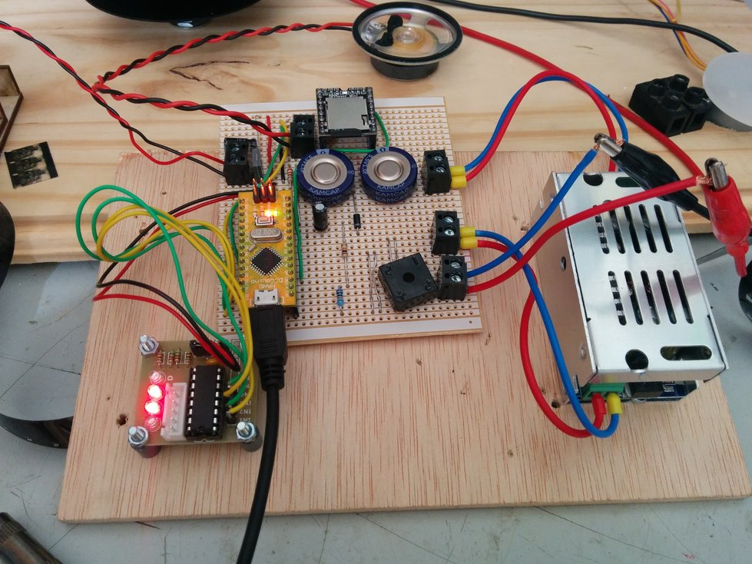

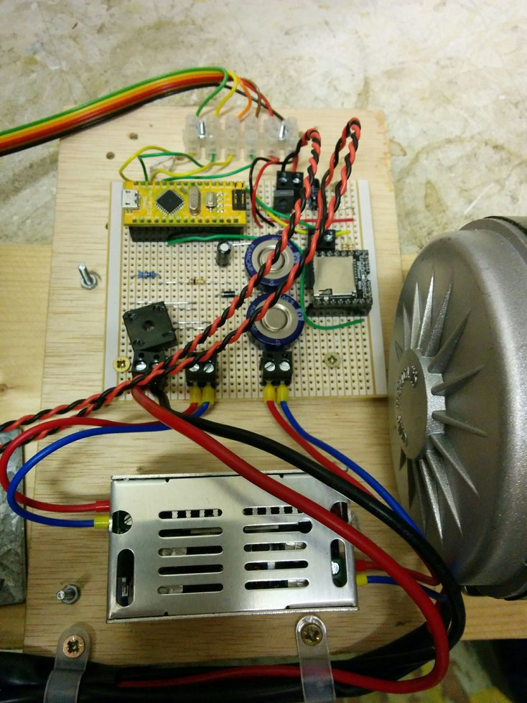

Sound Control
With each film there will be a sound track. This will be an mp3 sound file which is played when the cranks is turned (and there is enough power). It is paused when the crank is not spun.

A mp3 sound player unit is used and outputs stereo sound to an amplifier.
We are using a DFPlayer_Mini_Mp3. Lots of information is available here:
http://www.dfrobot.com/wiki/index.php/DFPlayer_Mini_SKU:DFR0299

Issue: When the cranking has stopped and the MP3 unit looses power then there is a loud 'popping' caused by the MP3 player. Unsure how to solve this.

Issue: The output from the mp3 unit needs to be amplified with a stereo amplifier.
A 3W 5V stereo amplifier will be used here. This has been ordered but not implemented.
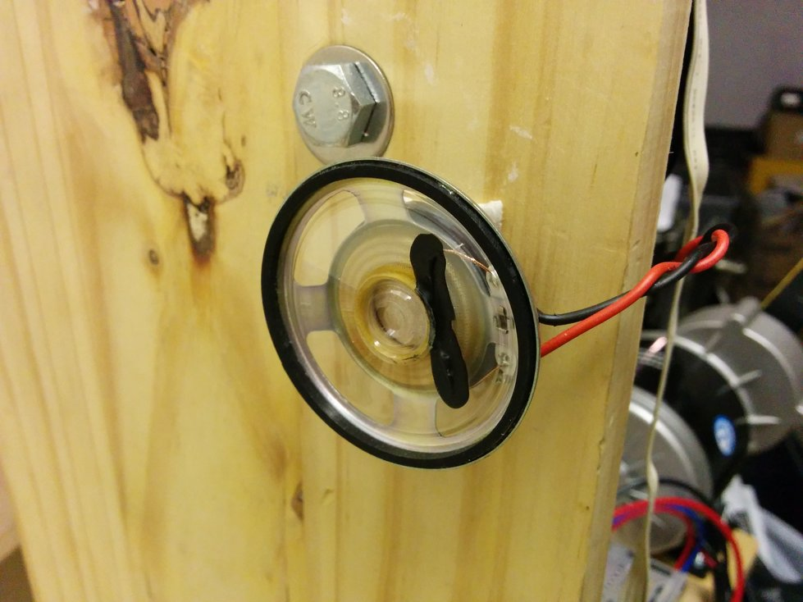

Testing
Here are some photos of the unit during the building and testing phase:

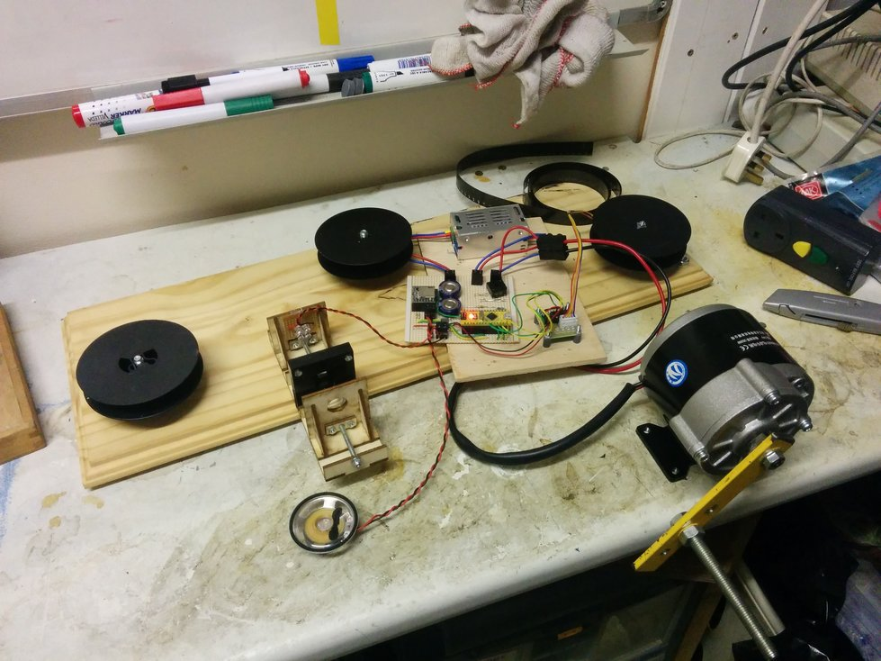

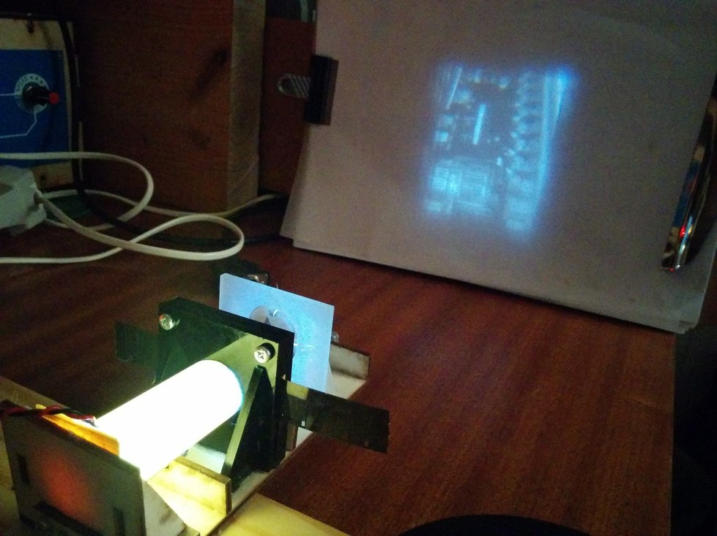

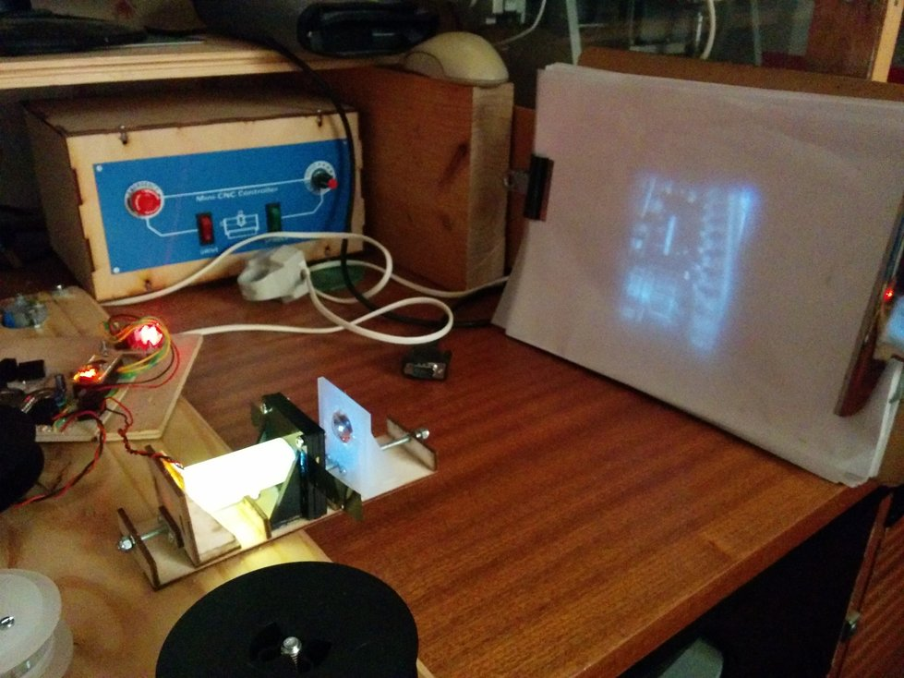

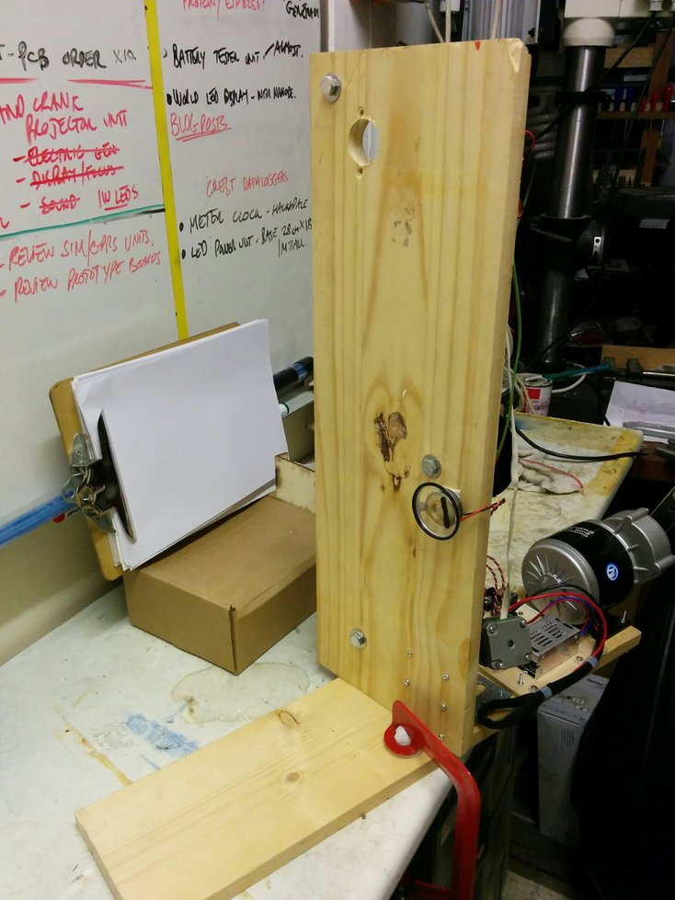

Appendix: Arduino Code

/*
Controller for Projection Unit
Project with Ben Wrigley

This unit controls a hand-cranked projection system.
When there is enough voltage then the unit will display a projected image
and start a mp3 track.
If the voltage drops then the sound will pause.
The stepper motor will move on the display by 1 frame and then flash the LED light.
This will happen at 6 frames per second (adjustable)

Code flow:

If crank voltage > v start setpoint
What is the ms counter?
LED off
Move 1 frame
LED On
Wait until 166mS passed (check ms counter)
else
Do nothing

This runs a stepper motor (or motors) from an Arduino Pro
5V ATMEGA328 16MHz (12MHz?)

I'm using the 28BYJ-48 stepper motor with driver
This Motor has a Gear ratio of 64 , and Stride Angle 5.625°
so this motor has a 4096 Steps .

Lots more info here:
http://42bots.com/tutorials/28byj-48-stepper-motor-with-uln2003-driver-and-arduino-uno/

Gear ratio is: 64 approx :1
Actual gear ratio: 63.68395 : 1

The PCB has the following wiring:

Stepper Motor is on:
D9,D10,D11,D12

LED output control is on D4

A0 This is the input voltage with a 100k/10k divider.

A SoundOut MP3 Audio Module (EA MOD 1021) from Embedded Adventures
http://www.embeddedadventures.com/soundout_mp3_module_mod-1021.html

The input voltage is monitored all the time.
This is used to record the last position of the motor before shutting down.
This means the unit can reset when powered up.

This example code is in the public domain.
*/
#include <EEPROM.h> // For writing values to the EEPROM
#include <avr/eeprom.h>
#include <SoftwareSerial.h>
#include <DFPlayer_Mini_Mp3.h>

//#include <AccelStepper.h>
//#define HALFSTEP 8
#include <Stepper.h>

// Motor pin definitions
#define motorPin1 9 // IN1 on the ULN2003 driver 1
#define motorPin2 10 // IN2 on the ULN2003 driver 1
#define motorPin3 11 // IN3 on the ULN2003 driver 1
#define motorPin4 12 // IN4 on the ULN2003 driver 1

#define ledPin 4 // LED output control
#define voltageMonitor A0 // This is the pin to measure the voltage on the input

// Sound Module Connections
#define TX 6 //
#define RX 5 //
#define tuneBusy A1 // Measure when the audio module has finnished.

// Define the MP3 Module's Commands that we'll be using
#define cmdNextTrack 0x01 // Next track.
#define cmdPrevTrack 0x02 // Previous track.
#define cmdRepeatPlay 0x11 // Repeat play.
#define cmdPause 0x0E // Pause Play
#define cmdPlay 0x0D // Play track

#define cmdSetVolume 0x06 // Set Volume to a specified value.
#define cmdSetEq 0x07 // Set Equalizer to a specified value.
#define cmdReset 0x0c // Reset MP3 Module.
#define cmdsdTracks 0x47 //
#define cmdLowPower 0x0A // Put module into Low Power mode

// ****************USER VARIABLES****************************************
// **********************************************************************

#define vStartSetpoint 140 // The setpoint for the unit starting up
#define moveDistance 20 // The number of pulses to move

// ************** STEPPED INPUT *******************

const int stepsPerRevolution = 130; // change this to fit the number of steps per revolution
//// for your motor

//// Stepper motor variables
//int maxSpeed = 200; // The maximum speed for the motor (typical values 200-800)
//int acceleration = 5000; // Acceleration of the motor (typical values (50 - 400)

// ********************* END OF USER VARIABLES***************************
// **********************************************************************

int led = 13; // LED on pin 13 - flash to make it obvious
int tune = 2; // This is the tune file to play
int sensorValue = 0; // Holds the busy pin sensor value.

unsigned long int timerCounter; // Holds the time for delay loop

unsigned long int movePosition = 0;

// Initialize with pin sequence IN1-IN3-IN2-IN4 for using the AccelStepper with 28BYJ-48
//AccelStepper stepper1(HALFSTEP, motorPin1, motorPin3, motorPin2, motorPin4);
//// initialize the stepper library on pins 8 through 11:
Stepper stepper1(stepsPerRevolution, motorPin1, motorPin3, motorPin2, motorPin4);

unsigned int volume = 15; // Starting MP3 module volume (0 - 31).

SoftwareSerial mp3(RX, TX); // RX, TX

boolean startUpFlag = HIGH; // Flag to start the mp3 player

void setup() {

// Initialise the PIR as a input with a pull up resistor

pinMode(voltageMonitor, INPUT);

pinMode(ledPin,OUTPUT); // Have the LED display an output

Serial.begin(115200);
stepper1.setSpeed(100);
// stepper1.setMaxSpeed(maxSpeed); // usual value = 500
// stepper1.setSpeed(maxSpeed); // usual value = 200
// stepper1.setAcceleration(acceleration); // usual value = 100

mp3.begin(9600); // Initialise software serial.
mp3_set_serial (mp3); //set Serial for DFPlayer-mini mp3 module
mp3_set_volume (volume);

}//--(end setup )---

void loop() {

if(analogRead(voltageMonitor)>=vStartSetpoint)
{
timerCounter = millis();
if(startUpFlag==HIGH)
{

// Want to start the MP3 player
// mp3_reset;
// delay(200);
mp3_set_volume (volume);
delay(200);
mp3_play();
Serial.println("Start MP3");
startUpFlag=LOW;
}

Serial.print("Voltage is:");
Serial.println(analogRead(voltageMonitor));

digitalWrite(ledPin,LOW);
digitalWrite(led,LOW);
//movePosition = movePosition+moveDistance;
//stepper1.moveTo(movePosition);
stepper1.step(moveDistance);
// while(stepper1.run())
// {
// }
digitalWrite(ledPin,HIGH);
digitalWrite(led,HIGH);
while(millis()<=timerCounter+166)
{
// Wait until 1/6 second passed
//do nothing
}
}
else if(analogRead(voltageMonitor)<(vStartSetpoint-20))
{
if(startUpFlag==LOW)
{
// Want to pause the MP3 player
mp3_pause();
Serial.println("Stop MP3");
startUpFlag=HIGH;
}
}

// // Sound start/pause
// mp3_reset;
// Serial.println("Tune Played");
// mp3_next ();
// delay(500);
// // Wait until track finished
// while(analogRead(tuneBusy)<=400) // Busy signal is ACTIVE LOW
// {
// for(int i=0;i<=10;i++)
// {
// delay(10);
// }
// Serial.println(analogRead(tuneBusy));
// }
}

